Task 5: Reconnaissance Simulation Assignment
Introduction
This report is about reconnaissance simulation active and passive reconnaissance where different tools would be used to gather information on https://wilsescybersecurity.com website. These open source intelligence tools include whois, nslookup, nmap, theHarvester and Google Dorking with the aim of discovering digital vulnerabilities and security gaps. Discovery screenshot, results, and mitigation are provided on wilsescybersecurity.com and these guide could increase their security to prevent the breached of sensitive information.
Phase 1: Digital Footprint Analysis
Goal: Collect intelligence about the organization's online presence using OSINT tools.
- Domain registration and ownership details
Whois wilsescybersecurity.com command was used to view domain name, IP address, email address, etc.
Godaddy registered WILSESCYBERSECURITY.COM on 2023-06-20
Wilsescybersecurity registry website will expire on 2025-06-20 that is in less than two weeks’ time. It is important for wilsescybersecurity.com to renew their website license before the expiry date to avoid bad guys from hijacking the website. They need to stay ahead of these guys always.
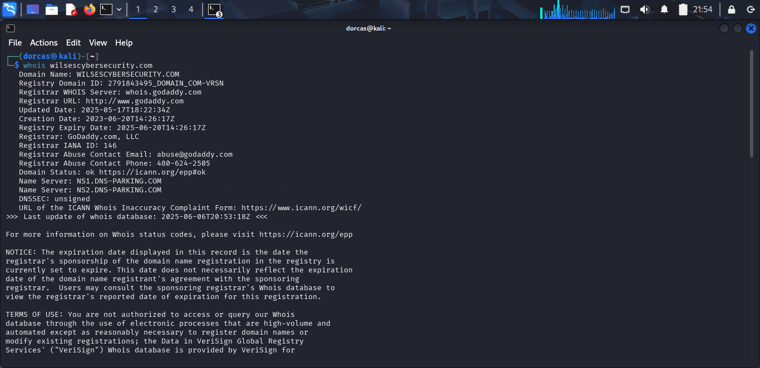

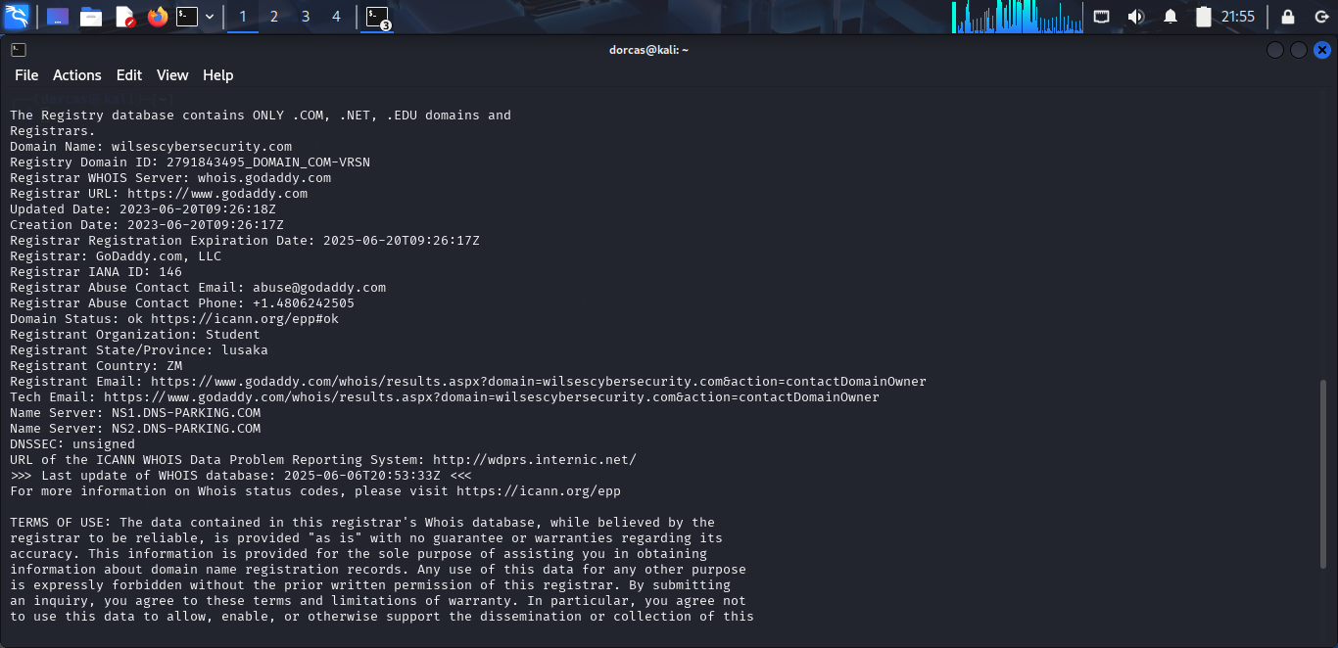
- Subdomains associated with the domain
In order to access wilsescybersecurity subdomains nslookup was installed in kali linux machine by using sudo apt install dnsutils command.
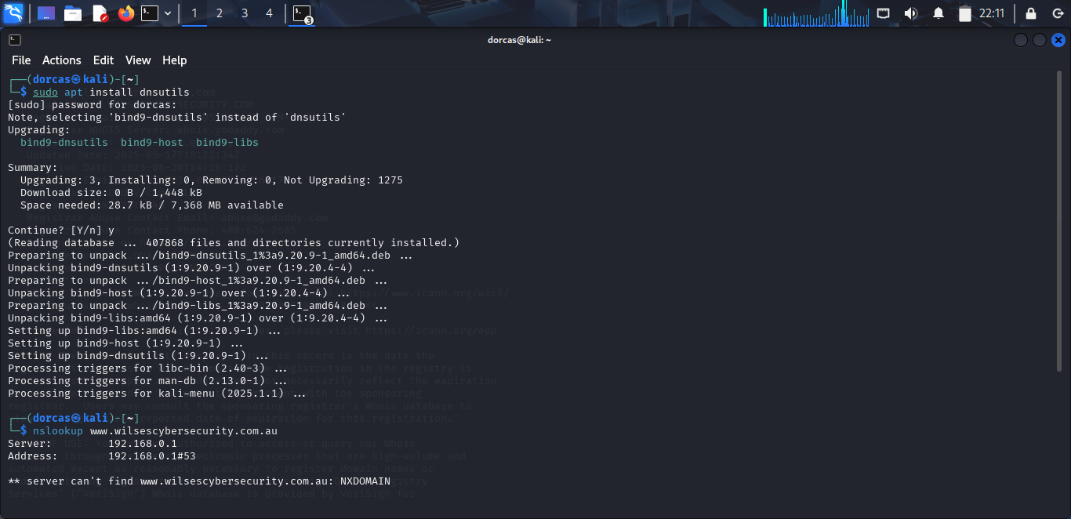
After that, nslookup www.wilsescybersecurity.com was used to check the subdomains associated with the domain from the screen shot below it is obvious that Wilses cybersecurity has two subdomain addresses.
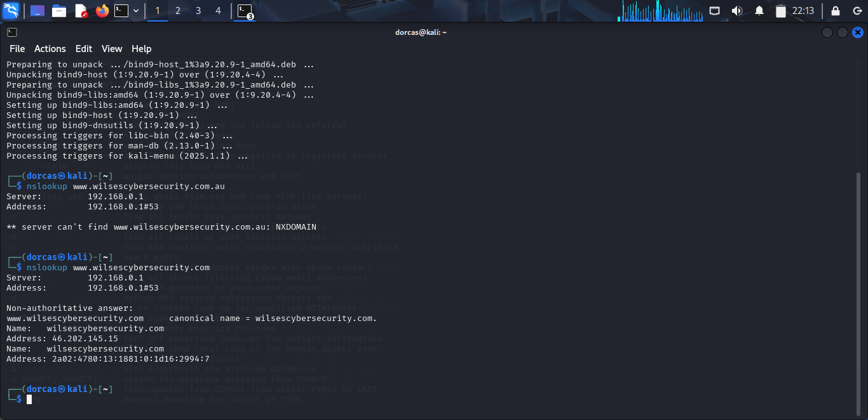
- Publicly available email addresses – To lookup for an email address, theHarvester –d/--domain command prompt was used. From the pentest scan there is no IP address, email and host found.
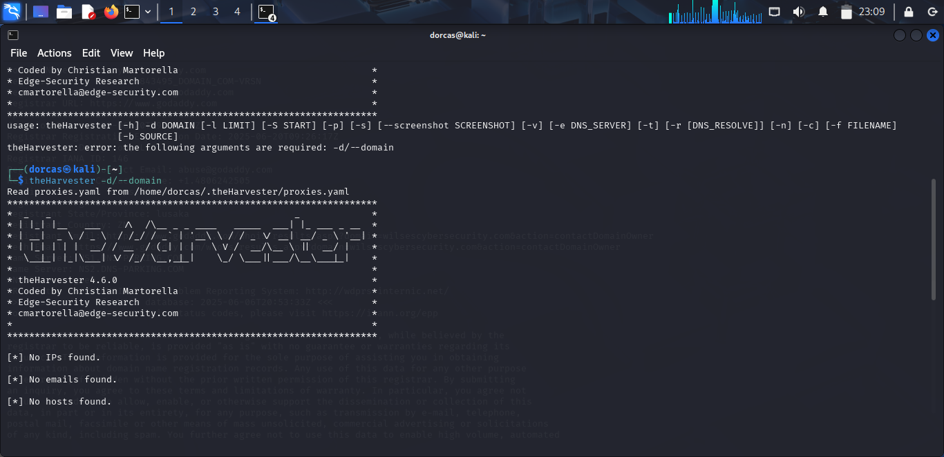
- Open ports and running services – nmap tool was used to check for open ports and if there is any service running with this command prompt nmap –Pn 192.168.0.1. 192.168.0.1 is Wilsescybersecurity.com IP address. No host is up and only 1 IP address is found.
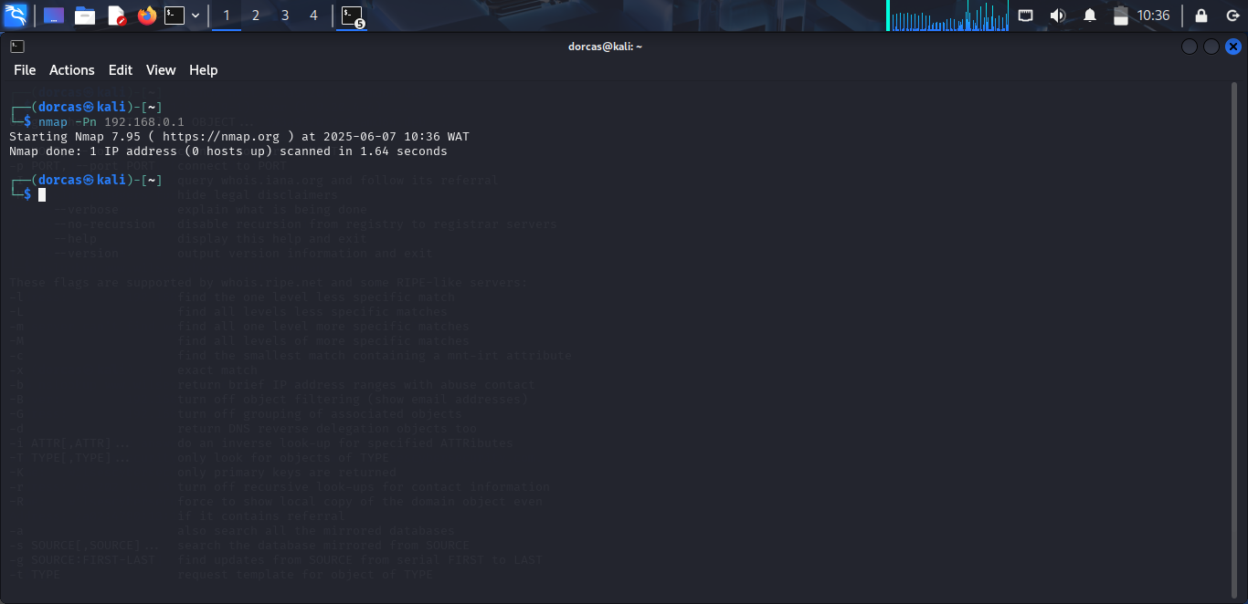
Digital footprint analysis results
Findings | Whois | Nslookup | theHarvester | Nmap
Domain registration/ownership | Yes
Subdomains associate with domain |  | Yes
Public emails | Yes |  | No
Open ports and running services |  |  |  | No
It is crucial to use multiple tools when conducting reconnaissance so to gather more information about the target because using a particular tool is not enough as we can see from the screenshot that theHarvester tool says no IP address, email and host found but in other tools we could find these information and many more about the organization.

Phase 2: Google Dorking & Open Web Discovery
Goal: Explore public search engine data to identify unintentionally exposed or sensitive information.
- Leaked or publicly accessible internal documents (e.g., PDFs, reports)
There is no leaked file found on Wilsescybersecurity.com website.
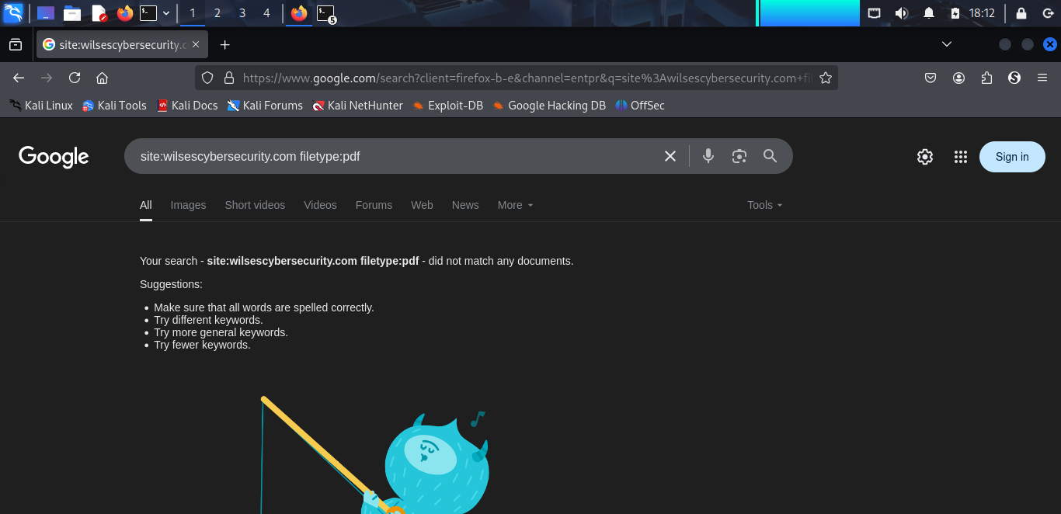
- Admin or backend login pages
When site:wilsescybersecurity.com:allintitle “login admin” was used in the search engine, wilsescybersecurity.com IP address came up and when I clicked on the first link it contains numerous default logins for 192.168.0.1.
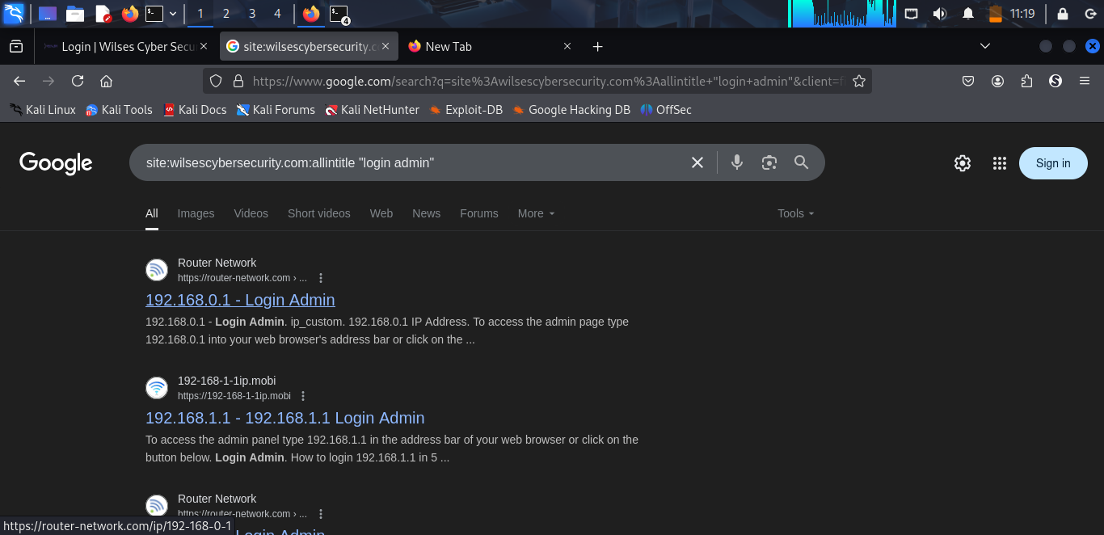
From the screenshot below, the admin logins are not secured this need to be changed and hidden as well.
The password usage is major security vulnerability.
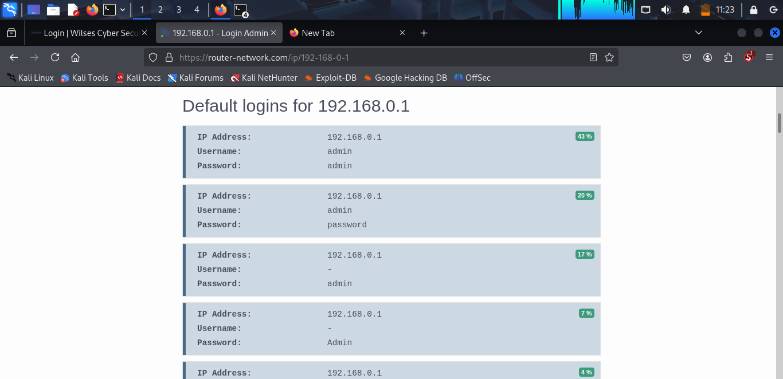
- Misconfigured directories or web pages with known vulnerabilities
A. Metasploit
Dirb https://wilsescybersecurity.com was used to identify wordlist_files, 4612 words were generated. Dirb https://wilsescybersecurity.com –R is used to identify the types of directories that exist, it says Option: Interactive Recursion Dirb https://wilsescybersecurity.com –X.php,.html,.htm to view file extension, it has 3 extension list.
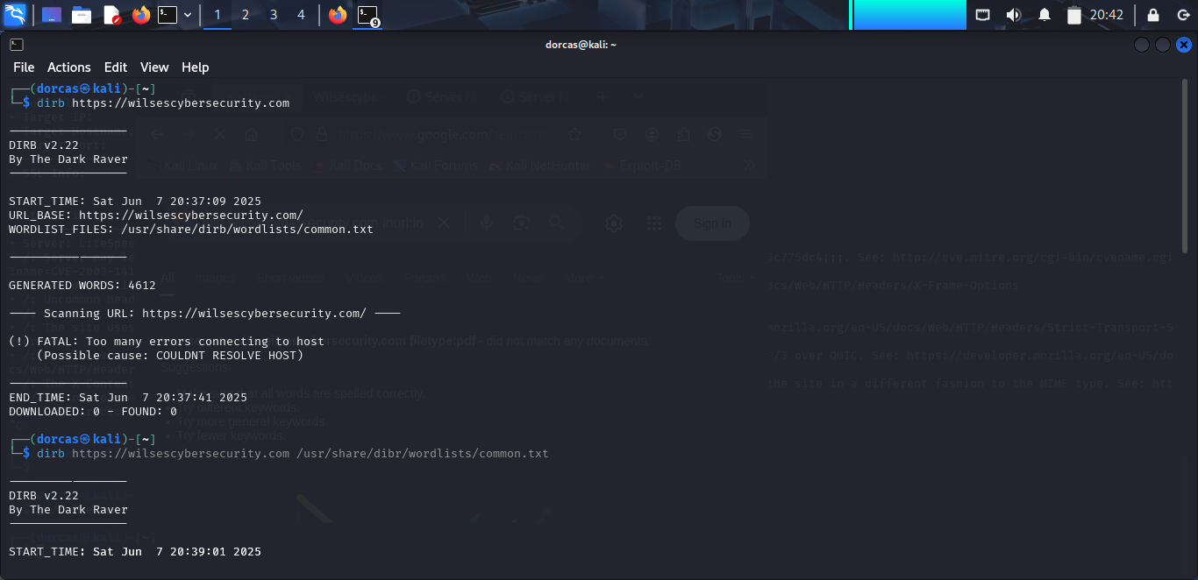
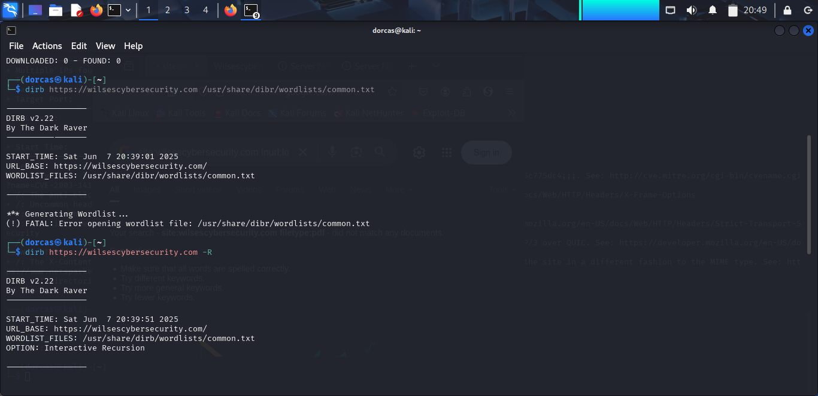
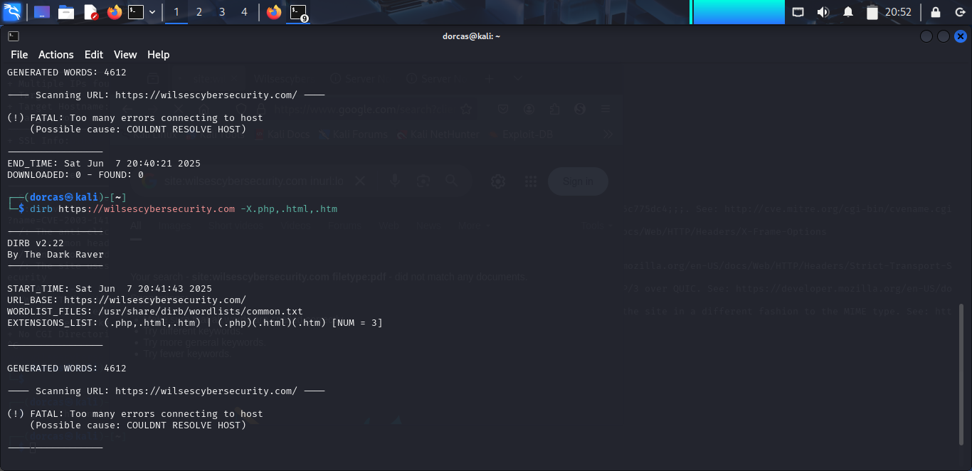
B. Nikto
Nikto v2.5.0 open-source intelligence tool was used to identify vulnerabilities on https://wilsescybersecurity.com. The command prompt used was nikto –h https://wilsescybersecurity.com
The name of the server is LiteSpeed, target port: 443, target hostname: wilsescybersecurity.com
The highlighted screenshot are the known vulnerabilities and misconfiguration on https://wilsescybersecurity.com
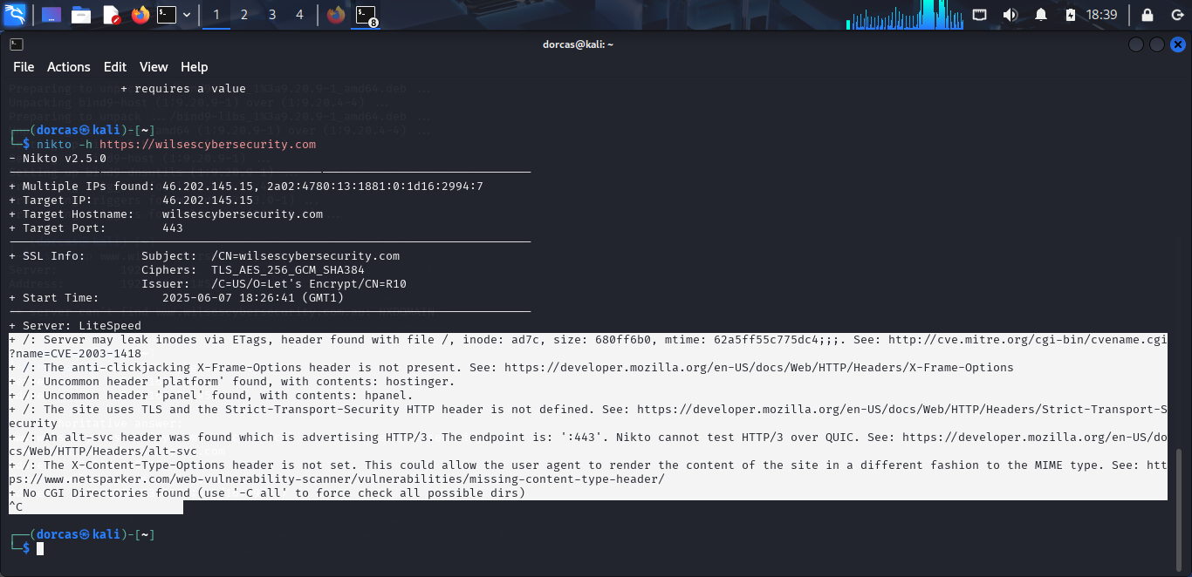
Recommendations
1. Implement client-side and server-side solution to combat anti-clickjacking.
2. Define TLS and the Strict-Transport-Security HTTP header.
3. Set X-Content-Type-Options properly.
4. Ensure to test HTTP/3 with security tool.
5. Prevent server from leaking inodes via Etags.
Open Web Discovery and Google Dorking Result
Sensitive information | Internal Document | Admin or backend login | Misconfigured directories or web pages
Vulnerabilities | No | Yes (Password exposed ) | Yes
IP address | No | Yes | Multiple IPs
Tool | Google Dorking | Google Dorking | Nikto and Metasploit

From the result, admin login details used admin and admin for their username and password which is not a secured password. It is easy to guess the password. It is advisable to use alphanumeric and special character password with minimum of 8 – 12 password. That is a good and strong password.
IP address was display by Google Dorking and Nikto. Both passive and active reconnaissance was conducted.

Mitigation
1. Use a strong password between 8 – 12 characters.
2. Renew the website registration before expiry date.
3. Update both system and software regularly.
4. Conduct frequent website auditing and monitoring for vulnerabilities and Google Dorking attempts.
5. Protect web servers and sensitive data, this should be kept internally and secured.
6. Encrypt all your sensitive data to prevent unauthorized access.
7. Educate Wilses Cybersecurity staff on how to handle sensitive information and create awareness about Google Dorking.
8. Use firewall and security tools to prevent and detect unauthorized access attempt and any suspicious activities on the website.
9. Use SIEM tools to detect port scanning in your network.
Conclusion
To sum up, both active and passive reconnaissance tools were used to gather information, scan for vulnerabilities and results for each phases was outlined when the above recommendation and mitigation is incorporated, https://wilsescybersecurity.com website will be more secured from threat actors. Act immediately!

